II B. Tech I Semester (Regulation: VCE R-22), ACADEMIC YEAR 2023 – 24
ENGINEERING DESIGN THINKING (A8023) - Common to All Branches
CENTER FOR INNOVATION AND ENTREPRESUHIP
FARM TECH BATCH NO: 4
Problem Statement | SDG’s covered | Flow of Execution
1.Our project aims to provide farmers with easy access to required vehicles for farming through a user-friendly website, ultimately improving their efficiency and productivity.  2.Not only cities even in villages the farmers should get access of receiving all the modern technologies. | Empowering Indian farmers with vehicles aligns with sustainable Development Goals (SDGs):1(no poverty),2(zero hunger),8(decent work and Economic Growth) 9(industry, innovation, and infrastructure). This initiative improves productivity, reduces food waste, creates jobs, and enhances transportation infrastructure. | 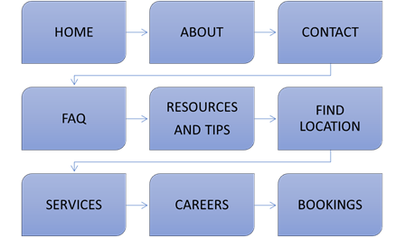
Target Audience | Existing Solution
Our main target audience are farmers.  1.By using this website the farmers may not get cheated through the change of prices by owners.  2.Farmers can be aware of the market prices for their crops.  3.Farmers can be able to get the required vehicle at the right time with the actual charge of the vehicles or equipments. | One existing solution for providing vehicles to farmers in India is Trringo. Trringo is a platform that offers farm equipment and vehicles on rent, making it more accessible for farmers who may not be able to afford outright purchases.
 | Proposed Solution
 | Create a user-friendly website where farmers in India can browse and request vehicles for agricultural purposes. Implement a simple registration process, include a diverse range of vehicles, and ensure transparent pricing and delivery options. Integrate a feedback system for farmers to review and share their experiences, fostering trust and reliability.
Roll number & Names of the Students: Name of the Mentor(s):
1. 22881A05D3-NARENDAR Ms. M. Srilatha / Dr. Ravindra Eklarker
2. 22881A05E0-CHILKAMARI DIVYA
3. 22881A05F1-SHIREESHA
4. 22881A05F3-KEERTHAN
5. 22881A05F8-SHANAWAZ

